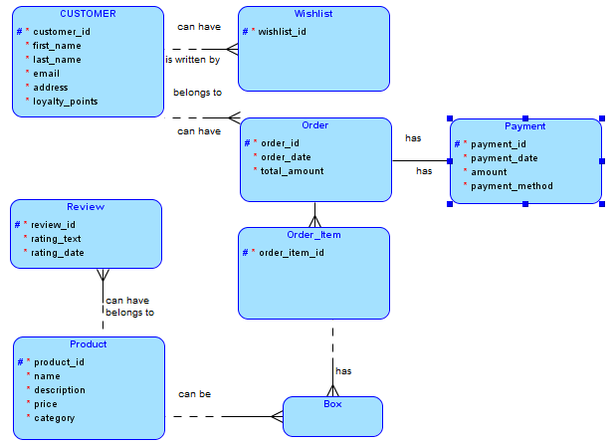
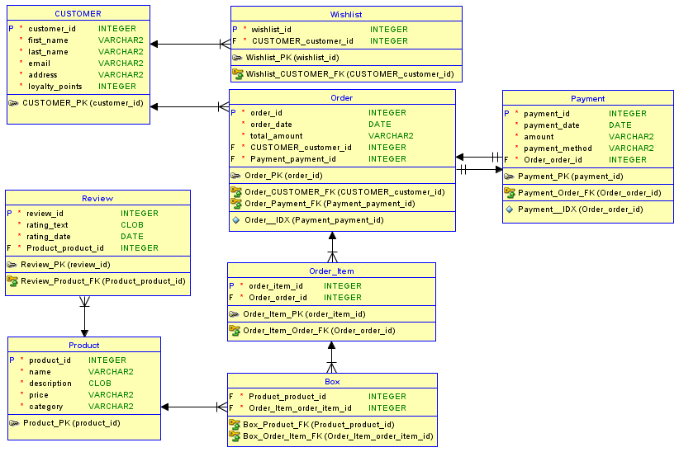

CREATE TABLE Customer_OnlineShop(  customer_id NUMBER(8) Primary Key,  first_name CHAR(40),  last_name CHAR(40),  email VARCHAR(255),  address VARCHAR(255),  loyalty_points NUMBER(8)  ); | 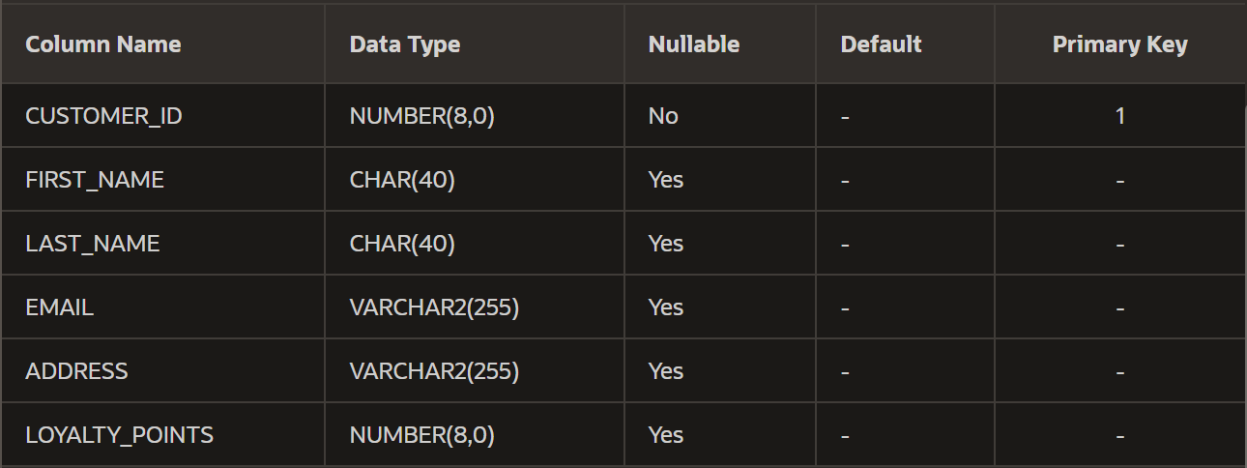
CREATE TABLE Product_OnlineShop(  product_id NUMBER(8) Primary Key,  name CHAR(40),  description VARCHAR(255),  price NUMBER(8,2),  category VARCHAR(255)  ); | 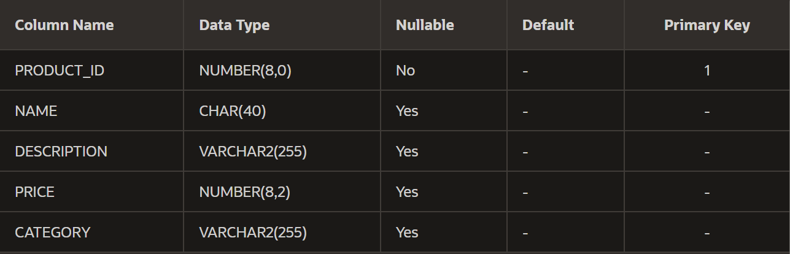
CREATE TABLE Order_OnlineShop(  order_id NUMBER(8) Primary Key,  customer_id NUMBER(8),  order_date DATE,  total_amount NUMBER(8,2)  ); | 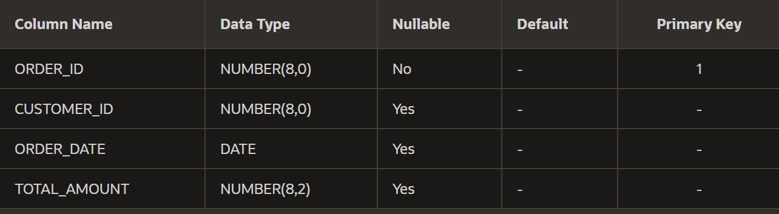
CREATE TABLE Order_Item_OnlineShop(  order_item_id NUMBER(8) Primary Key,  order_id NUMBER(8),  product_id NUMBER(8)  ); | 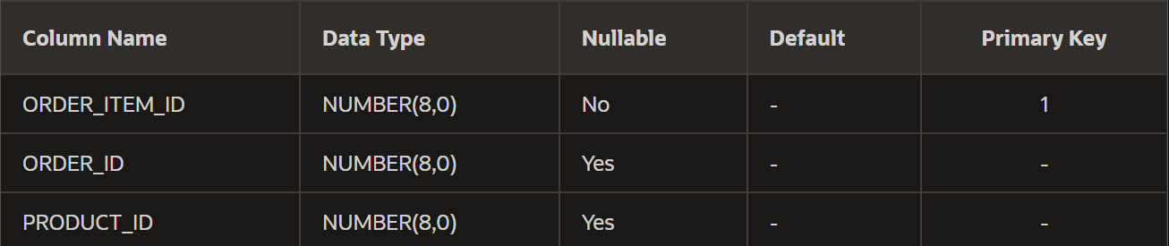
CREATE TABLE Wishlist_OnlineShop(  wishlist_id NUMBER(8) Primary Key,  customer_id NUMBER(8),  product_id NUMBER(8)  ); | 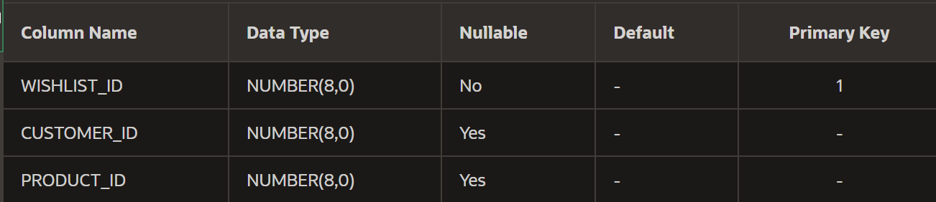
CREATE TABLE Review_OnlineShop(  review_id NUMBER(8) Primary Key,  customer_id NUMBER(8),  product_id NUMBER(8),  review_text VARCHAR(255),  review_date DATE  ); | 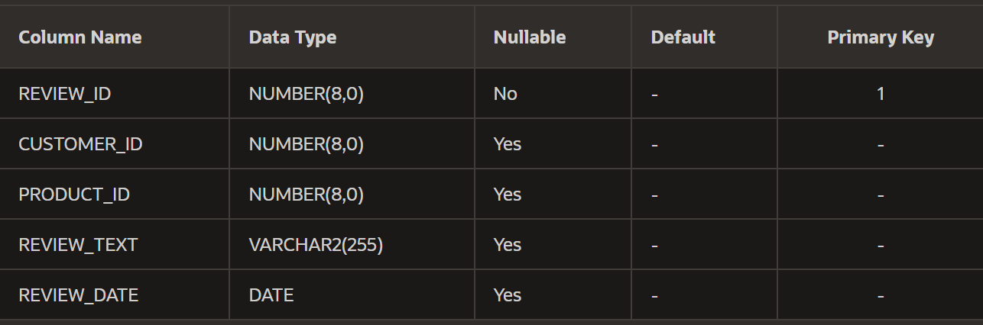
CREATE TABLE Payment_OnlineShop(  payment_id NUMBER(8) Primary Key,  order_id NUMBER(8),  amount NUMBER(8,2),  payment_method VARCHAR(255),  payment_date DATE  ); | 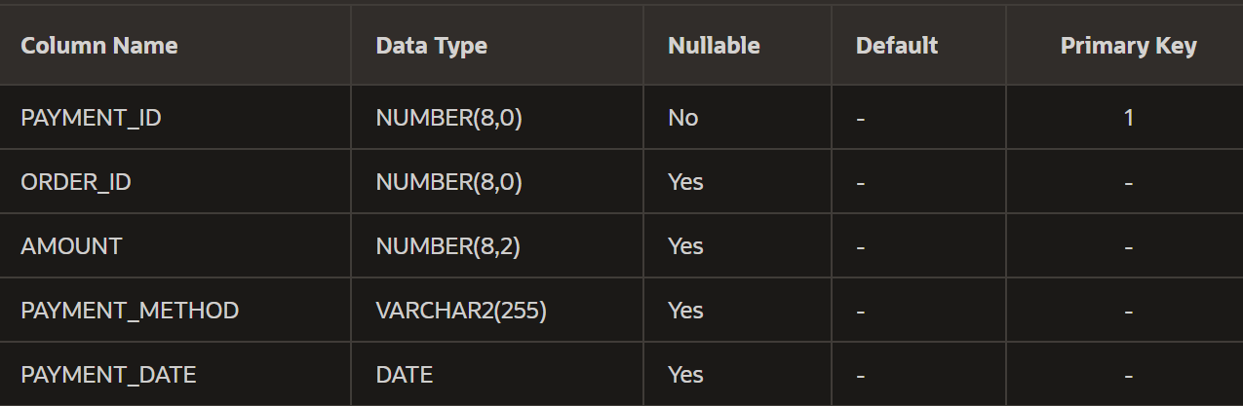

insert all into Customer_OnlineShop
VALUES (1, 'John', 'Doe', 'john.doe@email.com', '123 Elm St', 100)
INTO Customer_OnlineShop VALUES (2, 'Jane', 'Smith', 'jane.smith@email.com', '456 Oak St', 150)
INTO Customer_OnlineShop VALUES (3, 'Mike', 'Johnson', 'mike.johnson@email.com', '789 Pine St', 200)
INTO Customer_OnlineShop VALUES (4, 'Sara', 'Lee', 'sara.lee@email.com', '101 Maple St', 50)
INTO Customer_OnlineShop VALUES (5, 'David', 'Kim', 'david.kim@email.com', '202 Birch St', 80)
select 1 from dual;
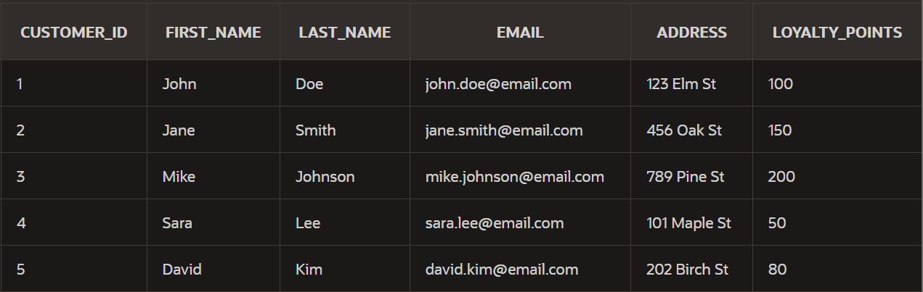

insert all into Product_OnlineShop
VALUES (1, 'The Great Gatsby', 'Classic novel by F. Scott Fitzgerald', 10.99, 'Books')
INTO Product_OnlineShop VALUES (2, 'To Kill a Mockingbird', 'Harper Lee masterpiece', 8.99, 'Books')
INTO Product_OnlineShop VALUES (3, '1984', 'George Orwell dystopian novel', 12.50, 'Books')
INTO Product_OnlineShop VALUES (4, 'Pride and Prejudice', 'Jane Austen romantic classic', 7.75, 'Books')
INTO Product_OnlineShop VALUES (5, 'The Catcher in the Rye', 'J.D. Salingers iconic novel', 11.25, 'Books')
select 1 from dual;
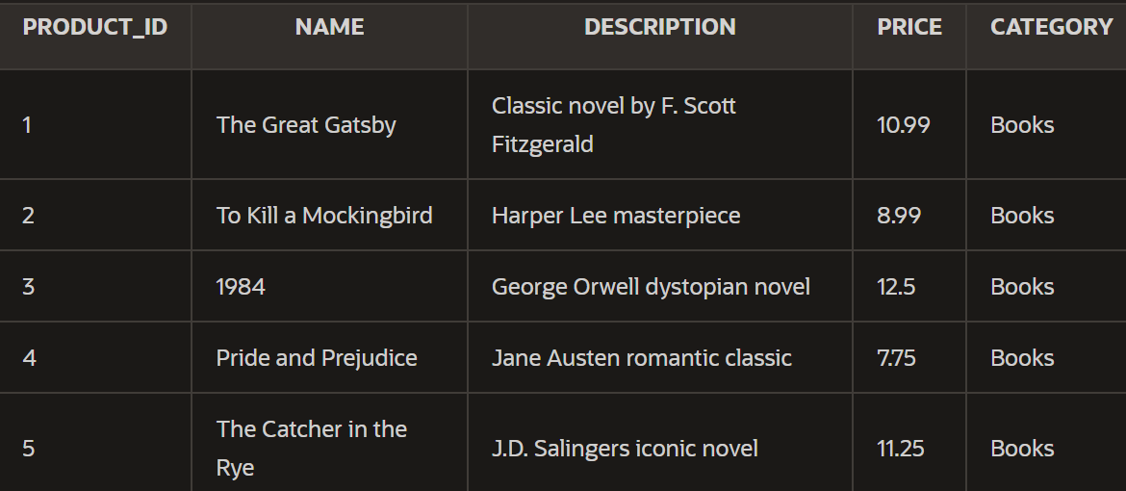

insert all into Order_OnlineShop
VALUES (1, 1, '01-MAY-2015', 28.99)
INTO Order_OnlineShop VALUES (2, 2, '01-JAN-2016', 25.99)
INTO Order_OnlineShop VALUES (3, 3, '01-JUN-2016', 30.00)
INTO Order_OnlineShop VALUES (4, 4, '01-AUG-2016', 18.50)
INTO Order_OnlineShop VALUES (5, 5, '01-SEP-2016', 35.75)
select 1 from dual;
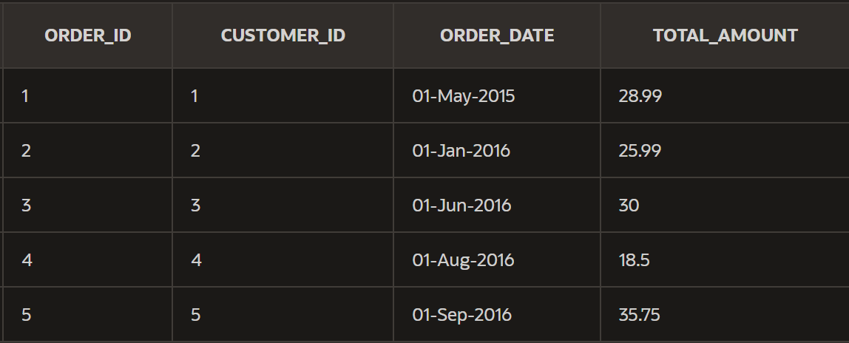

insert all into Order_Item_OnlineShop
VALUES (1, 1, 1)
INTO Order_Item_OnlineShop VALUES (2, 1, 3)
INTO Order_Item_OnlineShop VALUES (3, 2, 2)
INTO Order_Item_OnlineShop VALUES (4, 3, 4)
INTO Order_Item_OnlineShop VALUES (5, 4, 5)
select 1 from dual;
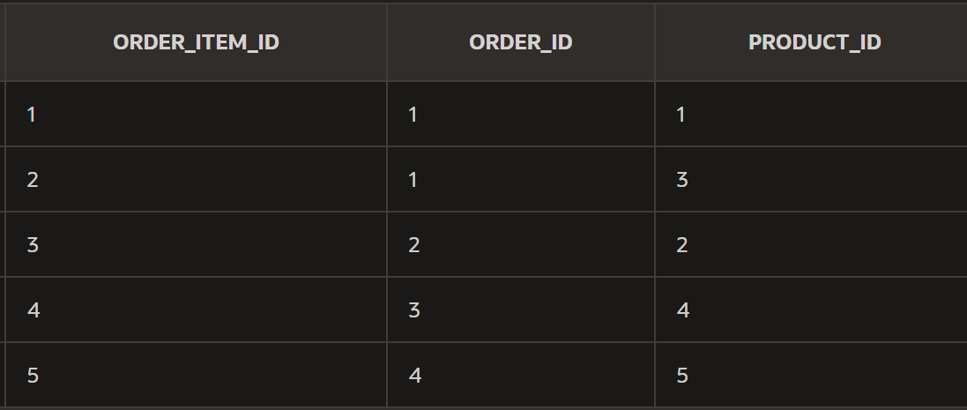

insert all into Wishlist_OnlineShop
VALUES (1, 1, 2)
INTO Wishlist_OnlineShop VALUES (2, 2, 5)
INTO Wishlist_OnlineShop VALUES (3, 3, 1)
INTO Wishlist_OnlineShop VALUES (4, 4, 3)
INTO Wishlist_OnlineShop VALUES (5, 5, 4)
select 1 from dual;
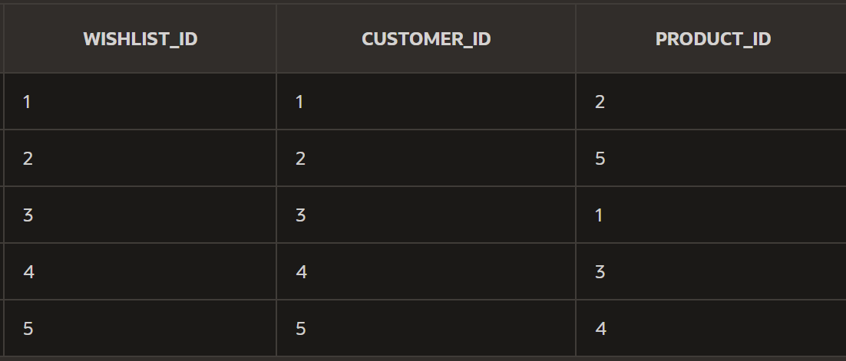

insert all into Review_OnlineShop
VALUES (1, 1, 1, 'Great book!', '01-MAY-2015')
INTO Review_OnlineShop VALUES (2, 2, 2, 'Amazing story!', '01-JAN-2016')
INTO Review_OnlineShop VALUES (3, 3, 3, 'A must-read!', '01-JUN-2016')
INTO Review_OnlineShop VALUES (4, 4, 4, 'Very interesting.', '01-AUG-2016')
INTO Review_OnlineShop VALUES (5, 5, 5, 'Loved the characters!', '01-SEP-2016')
select 1 from dual;
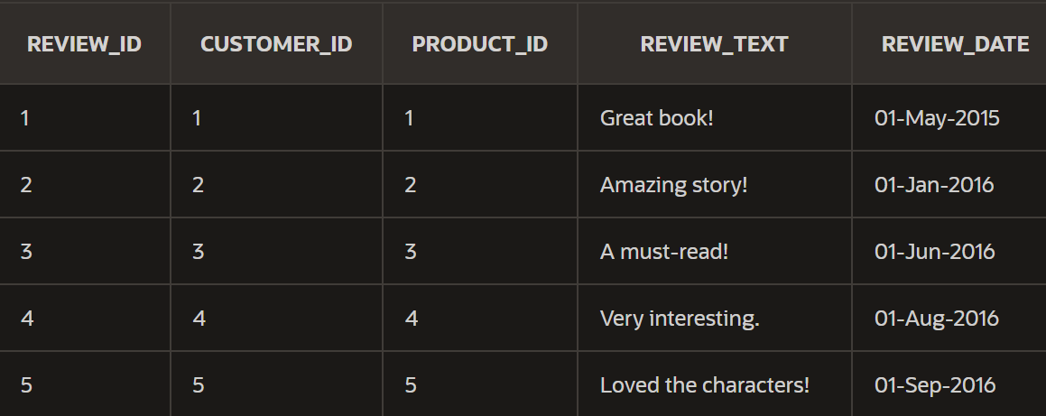

insert all into Payment_OnlineShop
VALUES (1, 1, 28.99, 'Credit Card', '01-MAY-2015')
INTO Payment_OnlineShop VALUES (2, 2, 25.99, 'PayPal', '01-JAN-2016')
INTO Payment_OnlineShop VALUES (3, 3, 30.00, 'Cash', '01-JUN-2016')
INTO Payment_OnlineShop VALUES (4, 4, 18.50, 'Credit Card', '01-AUG-2016')
INTO Payment_OnlineShop VALUES (5, 5, 35.75, 'Credit Card', '01-SEP-2016')
select 1 from dual;
